Famous last words in data: 💀
"I know Pandas."
Most analysts use 3 functions daily.
Then panic in interviews.
Here's what separates them:
❌ df.head() to "explore" data
✅ df.info() + df.describe() together
Shows dtypes, nulls, and stats in one shot.
❌ Looping through rows manually
✅ df.apply() or vectorized operations
10x faster. Looks senior. Always.
❌ Googling merge vs join every time
✅ Know this cold:
merge() = SQL-style, join() = index-based.
❌ dropna() on everything blindly
✅ df.isnull().sum() first
Know WHERE the gaps are before acting.
❌ Hardcoding chart libraries
✅ df.plot(kind='bar') natively
Pandas has built-in viz. Most never use it.
❌ Sorting one column at a time
✅ sort_values(['col1','col2'], ascending=[True,False])
Multi-column sort in one line. Interview gold.
The brutal truth:
Pandas isn't hard to learn.
It's hard to learn completely.
This cheat sheet is the shortcut.
Every essential Pandas function is in this cheat sheet.
I made sure nothing was left out.
💾 𝗦𝗮𝘃𝗲 𝘁𝗵𝗶𝘀 𝗯𝗲𝗳𝗼𝗿𝗲 𝘆𝗼𝘂𝗿 𝗻𝗲𝘅𝘁 𝗶𝗻𝘁𝗲𝗿𝘃𝗶𝗲𝘄. 👇
---
♻️ Repost this to help others MASTER Pandas the easy way!
🔔 FOLLOW + Hit the Bell -> Anandnarayanan S for more about Data & AI
Activate to view larger image,
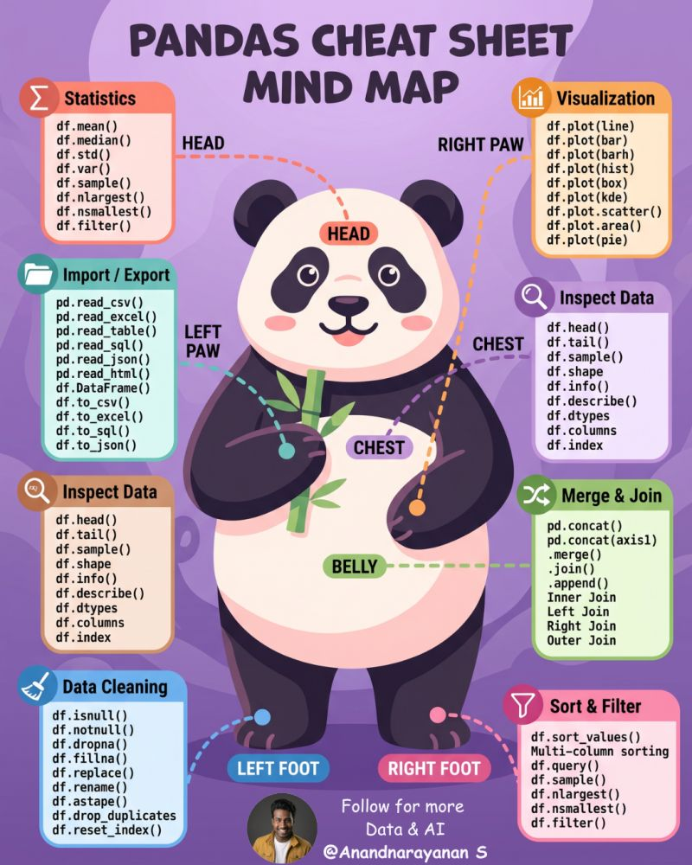

If you only learn 20 Pandas commands, make them these.
These handle most of your day-to-day data analysis tasks.
(📌 Save this cheat sheet. You'll come back to it every time you work with Pandas.)
Here's what every Python developer, data analyst, and data scientist should know:
📂 DATA EXPLORATION
↳ df.shape → Get DataFrame dimensions
↳ df.head() → Preview the first 5 rows
↳ df.info() → View data types and missing values
↳ df.describe() → Generate summary statistics
🧹 DATA CLEANING
↳ df.dropna() → Remove missing values
↳ df.fillna() → Fill missing values
↳ df.drop() → Remove columns
↳ df.rename() → Rename columns
🔍 DATA SELECTION
↳ df['column'] → Select a single column
↳ df[['col1', 'col2']] → Select multiple columns
↳ df.loc[] → Select rows by label
↳ df.iloc[] → Select rows by position
↳ df.query() → Filter with readable conditions
📊 DATA ANALYSIS
↳ df.value_counts() → Count unique values
↳ df['column'].mean() → Calculate averages
↳ df.groupby().agg() → Group and summarize data
↳ df.sort_values() → Sort rows
🔄 DATA TRANSFORMATION
↳ df.merge() → Join DataFrames
↳ df.reset_index() → Reset row indexes
↳ pd.read_csv() → Load CSV files
💡 You don't need to memorize every Pandas command.
Master these 20 first.
They'll cover most of the data cleaning, exploration, and analysis you'll do with Pandas.
💬 𝗪𝗵𝗶𝗰𝗵 𝗣𝗮𝗻𝗱𝗮𝘀 𝗰𝗼𝗺𝗺𝗮𝗻𝗱 𝗱𝗼 𝘆𝗼𝘂 𝘂𝘀𝗲 𝘁𝗵𝗲 𝗺𝗼𝘀𝘁?
---
♻️ Repost it to help your network learn SQL, PANDAS the EASY way!
🔔 Follow + Hit the Bell → ( Anandnarayanan S ) for more Python, SQL cheat sheets.
Activate to view larger image,
